**EXPERIMENT – 8**

**AIM:** - a) Simulate Virtual LAN configuration using CISCO Packet Tracer Simulation.

**Steps:**

Step 1: Build the network as shown in the topology.  
Step 2: Configure basic settings for each switch.

Step 3: Configure PC hosts.

Step 4: Test connectivity.

**OUTPUT: -**

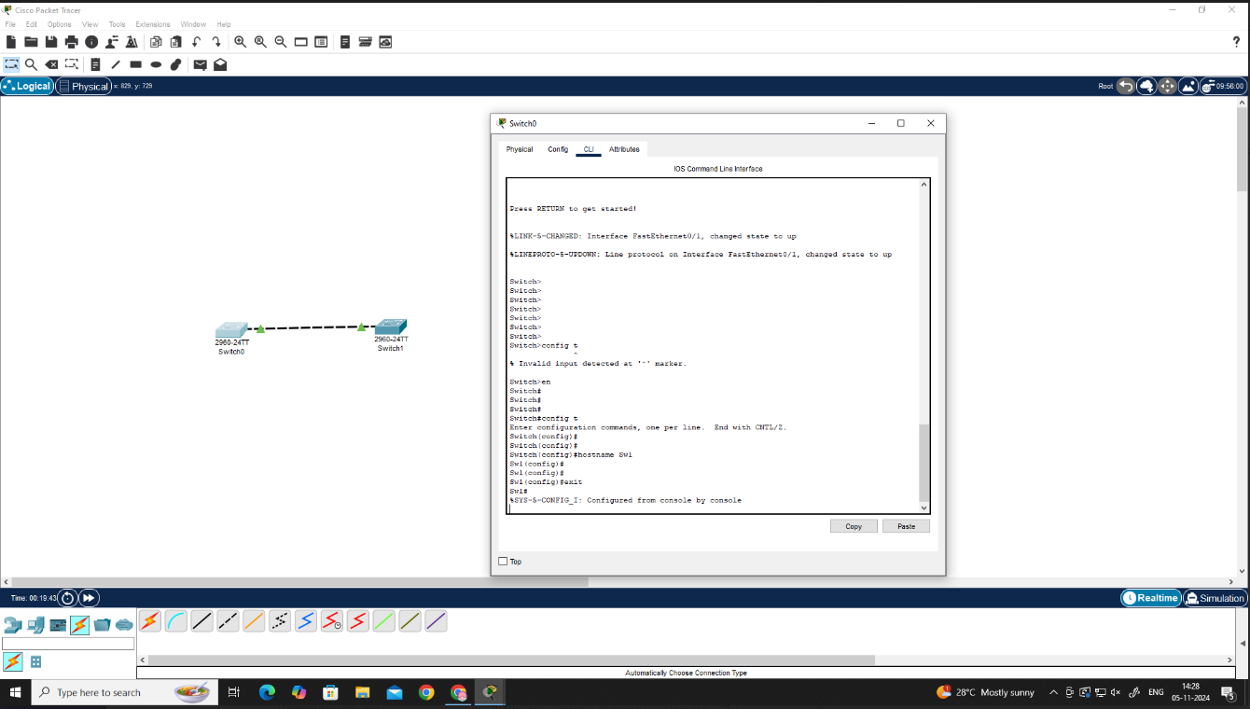

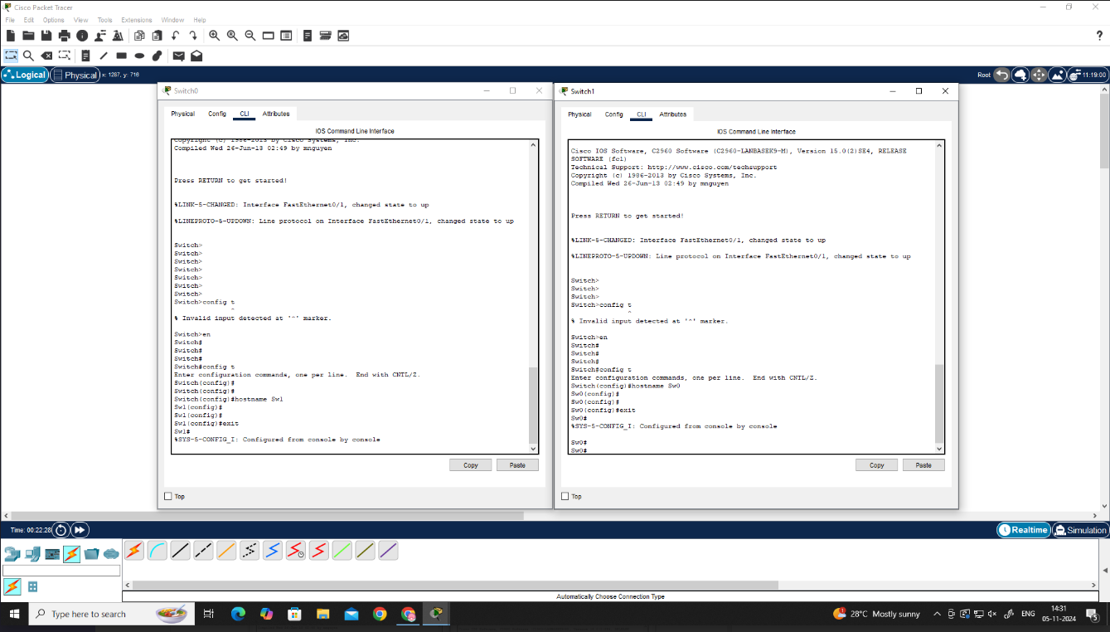

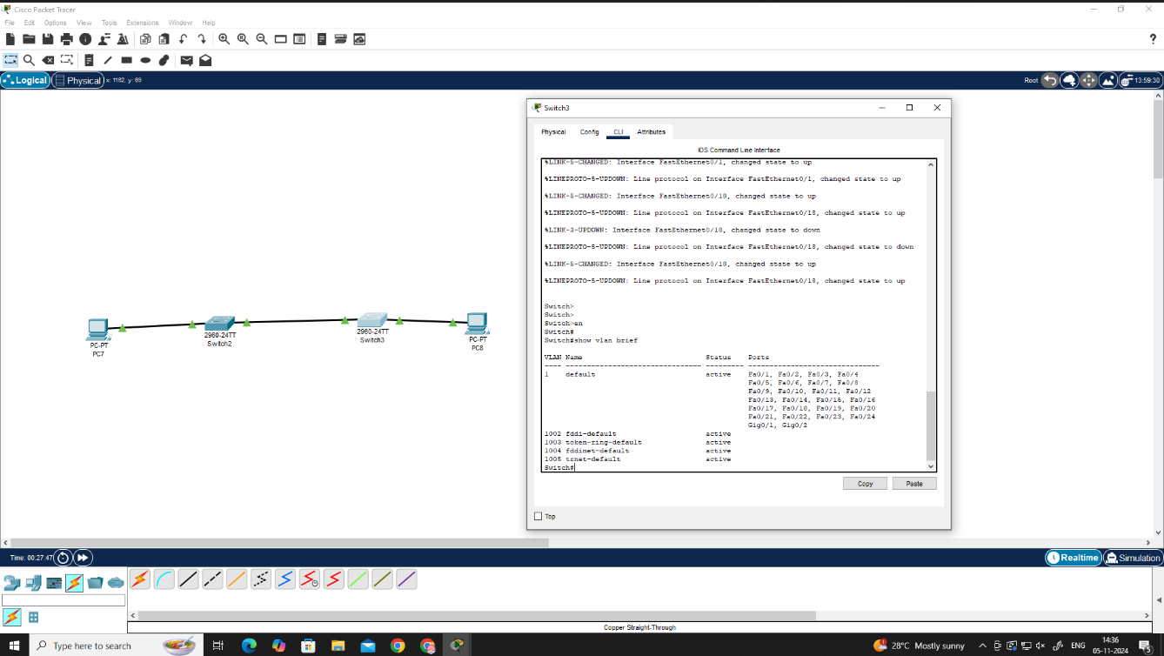

**RESULT: -**

Simulation of virtual LAN configuration have been done successfully.

**AIM:** - b) Configuration of Wireless LAN using CISCO Packet Tracer.

**Steps:**

* Configure Static IP on PC and Wireless Router
* Set SSID to MotherNetwork
* Set IP address of router to 192.168.0.1, PC0 to 192.168.0.2, PC1 to 192.168.0.3 and PC2 to 192.168.0.4.
* Secure your network by configuring WAP key on Router
* Connect PC by using WAP key

**OUTPUT: -**

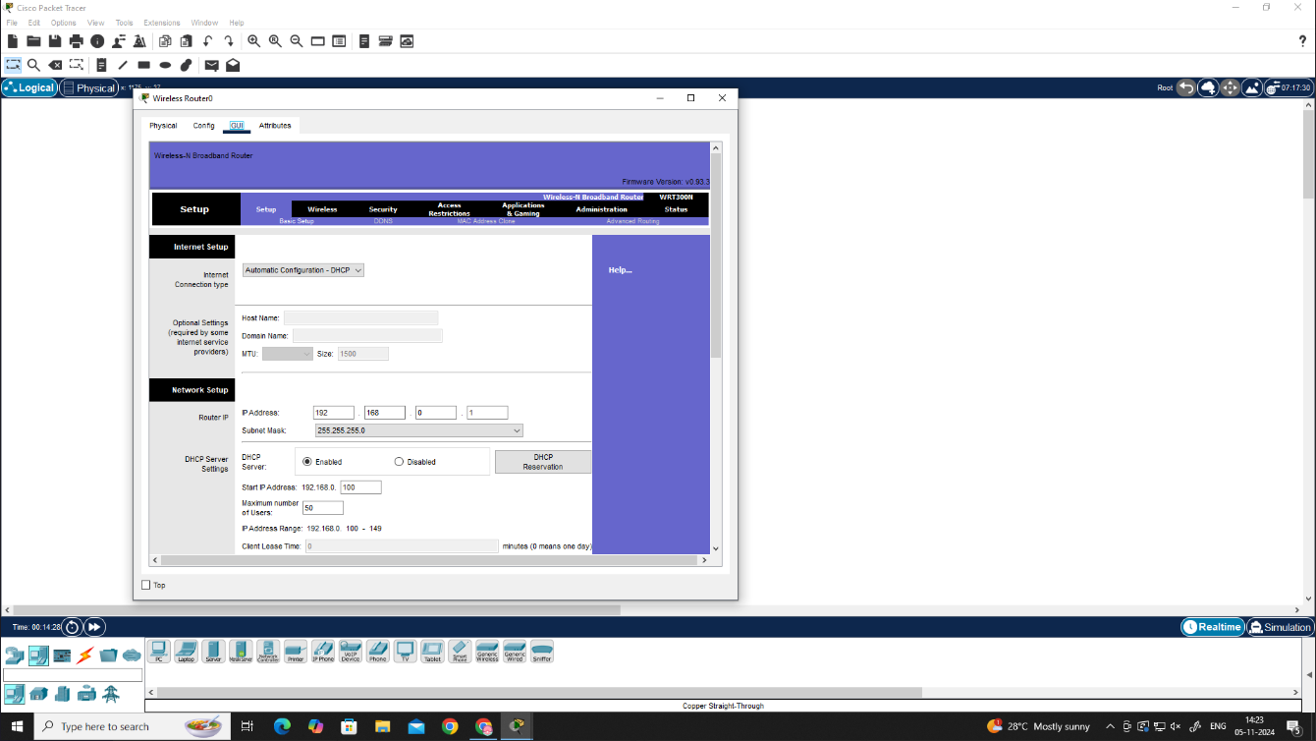

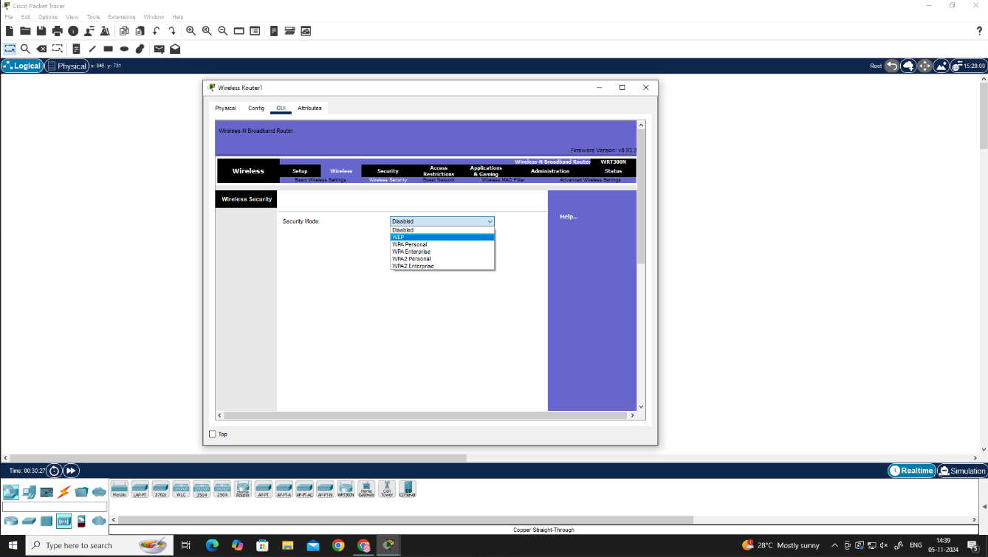

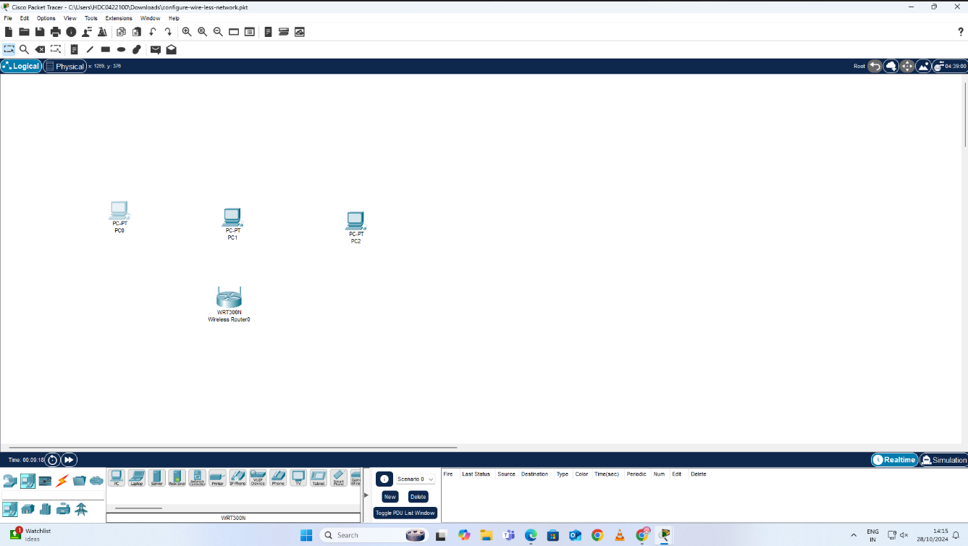

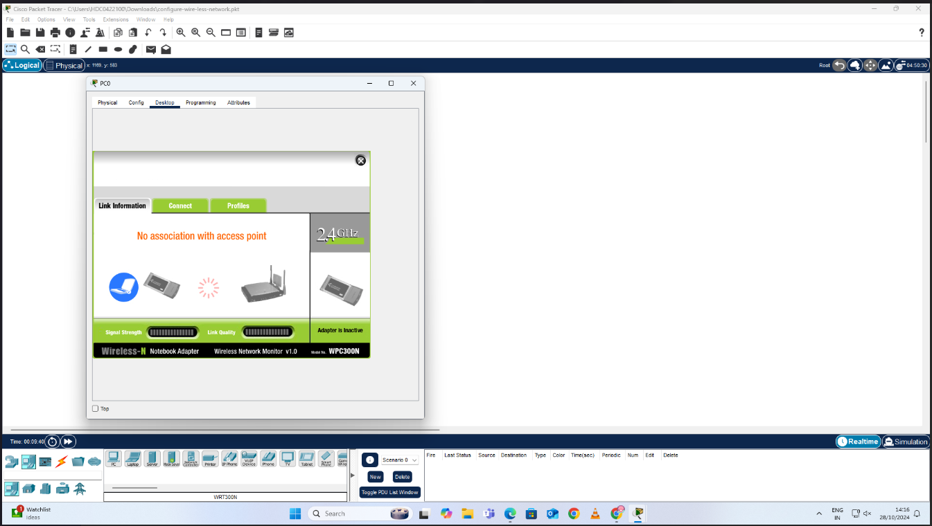

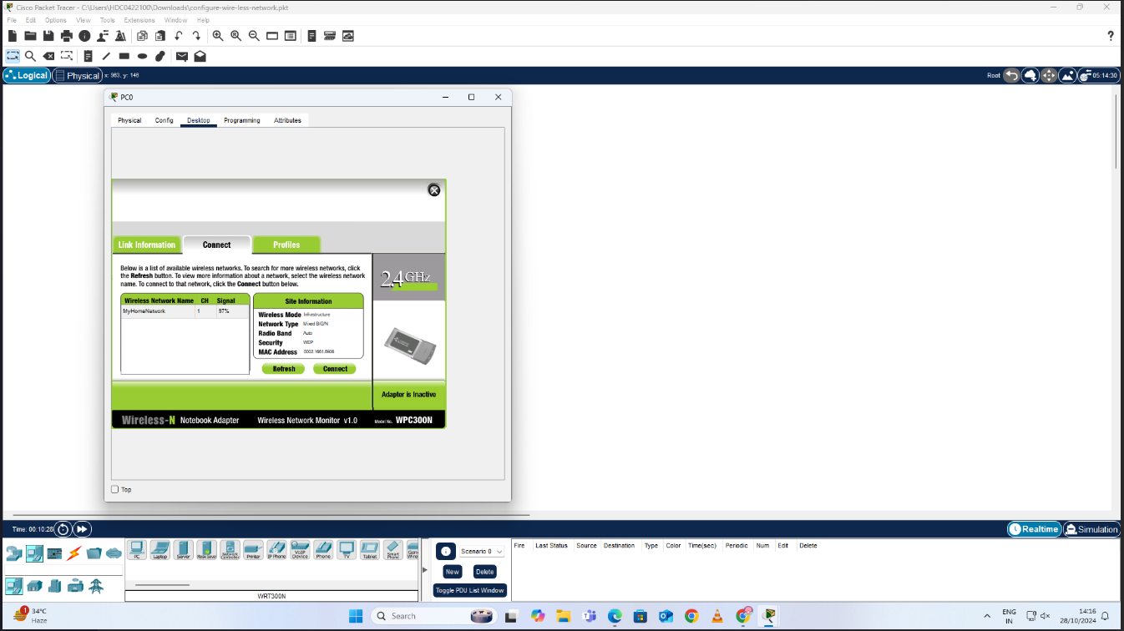

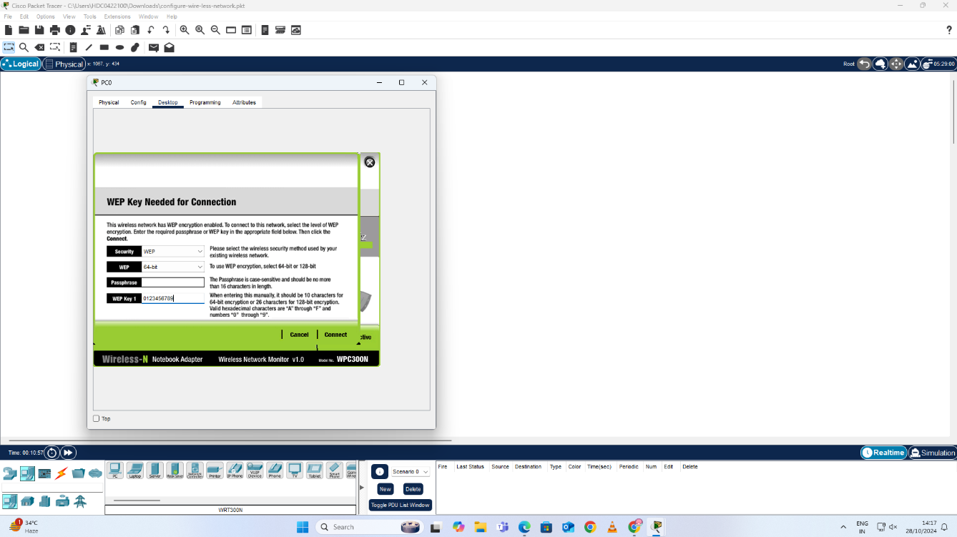

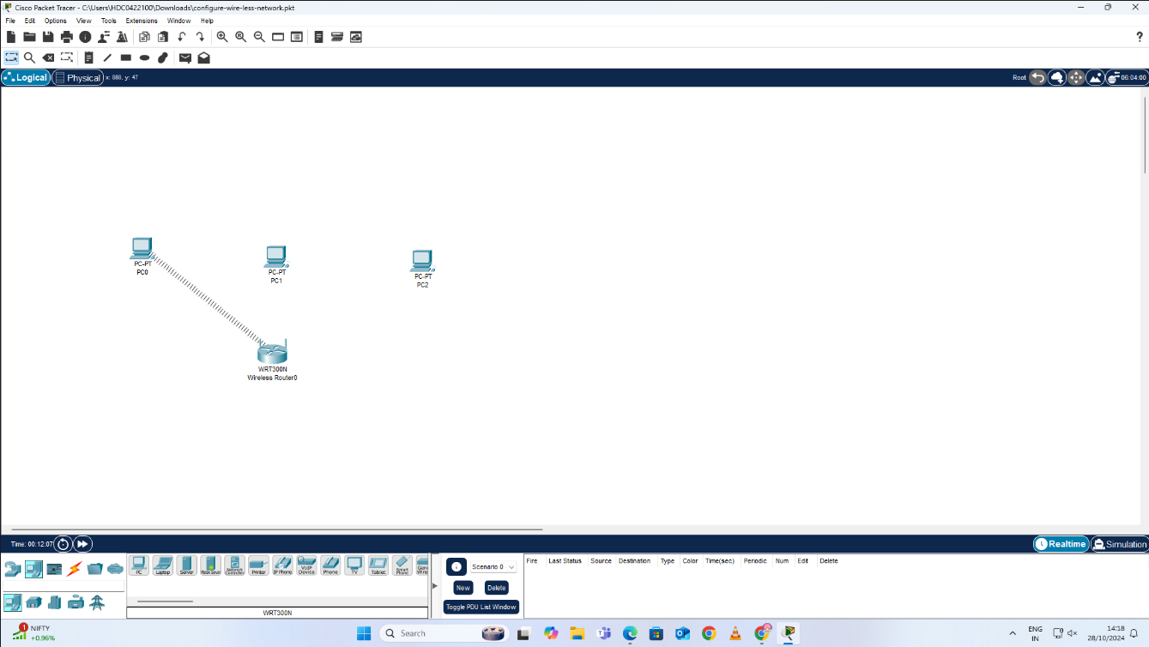

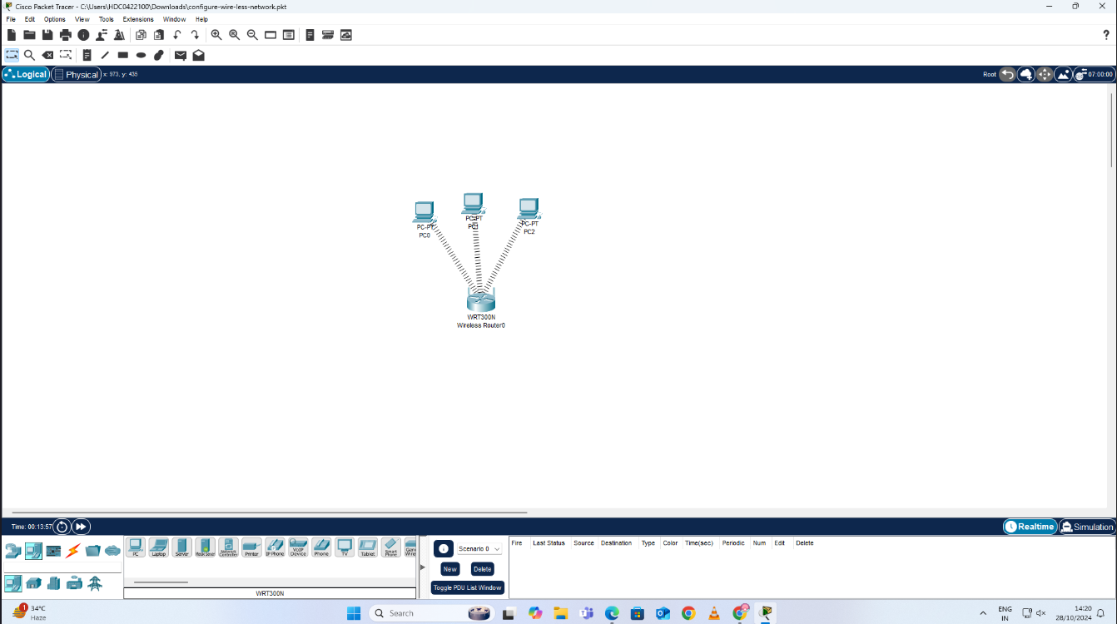

**RESULT: -**

Configuration of Wireless LAN using CISCO Packet Tracer have been done successfully and verified.